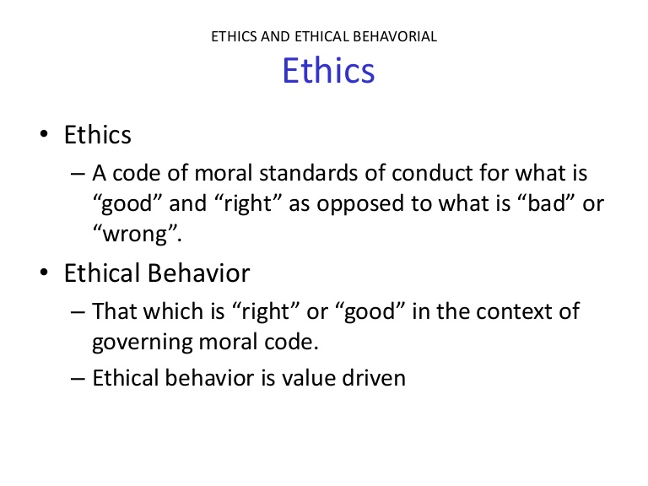

Different Influences on Individual Codes of Ethics
Directions: Be sure to include two examples in each column.
Ethics at Home | Ethics at School | Ethics at the Workplace

