Cooperative Education
Summative Activity - Part 1
Photo Display Assignment

Purpose: The purpose of this assignment is to demonstrate the learning experiences that you gained at your co-op placement.
This will give you an opportunity to highlight the skills you have learned and the people who have helped you obtain them.

Procedure: Explain the assignment to your employer and obtain his/her permission to bring a camera to your work placement. This is very important because of company confidentiality.

You may use your own camera or sign out one from the school (sign out sheet in coop office).
Take photos depicting:
- the signs in front of your work place (identify your placement)
- you in action ( working on a project)
- any projects you have completed
- your co-workers
- any other relevant photos

The Poster: Create a neat, organized and well laid out poster. Your poster must have a title with the name of the workplace. Each picture must have a typed caption explaining the relevance of the picture - please CHECK YOUR SPELLING!!

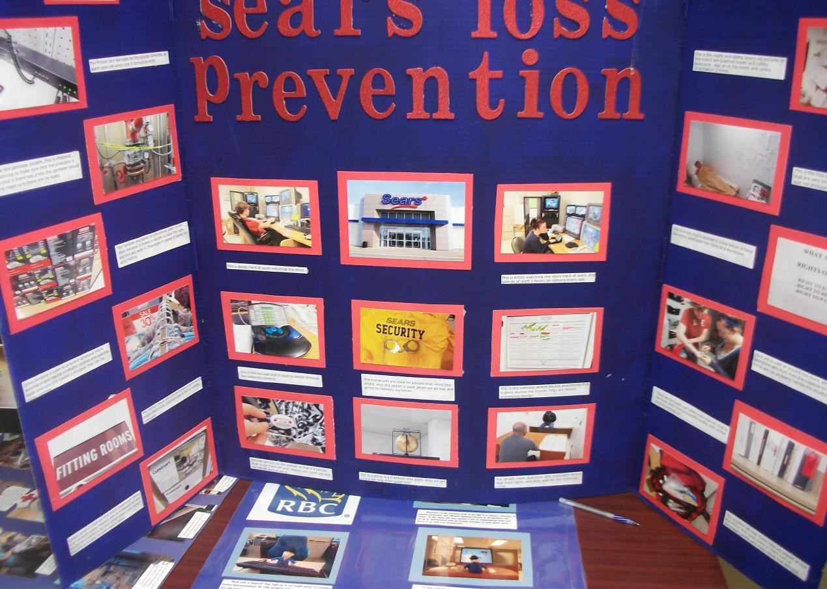

Cooperative Education
Summative Activity - Part 2
Written Report

Name:
SECTION 1: LEAVING YOUR PLACEMENT
Please complete the following:
- Write your employer a thank-you letter
- Make up a new résumé, which includes your new skills

SECTION 2: YOUR GOALS
Summarize your plans after high school. (If you are staying another year, include that information as well.) o If you are planning to go to UNIVERSITY or COLLEGE, list at least 2 different schools that interest you and why. Include information such as name and location of school, name of program, length of program, admission requirements, job prospects when finished, tuition fees, living expenses (meal plans, residence etc.)

- If you are planning to look for an APPRENTICESHIP, list 2 trades that interest you and why. Include information such as name of the trade, duties performed, length of apprenticeship, and admission requirements. Explain, where you plan to live and how much you will need how much money you will need for living expenses (rent, food, transportation etc).

- If you are planning to go into the WORKPLACE, explain what type of work you are you looking for and why it would interest you. Explain how you plan to get a job (list at least 2 companies that you would like to work for and explain a bit about each company). Explain how much money you will need for living expenses (rent, food, transportation etc).

Websites:
www.electronicinfo.ca www.ontariocolleges.ca www.apprenticesearch.com

SECTION 3: SELF-ASSESSMENT EVALUATION
Answer the following questions relating to your Coop experience this semester.

- Did coop meet your expectations? Did it influence your future career plans. Be specific.

- Describe the job responsibilities you experienced at your coop placement which you found most beneficial and rewarding. Why did you find these to be rewarding?

- Discuss your employability skills at your work placement. In your evaluation, in which specific areas do you feel you have improved and indicate the improvement.

- What was the most important lesson(s) that you learned throughout your coop experience this semester? This lesson could be related to the tasks assigned to you or to life/work experience lessons you may have learned. How will you use this lesson in the future?

- Would you recommend this placement to future coop students? Refer specifically to learning opportunities. (Did you find that you had lots of opportunity to learn and practice new skills? Did you feel that you had adequate supervision and direction?

- What specific advice would you give to other students about the coop program and your workplace to guarantee success on the job? This advice could refer to tips for success on the job or tips for success in the classroom. Do you have any suggestions to improve the program?

RUBRIC FOR COOP SUMMATIVE ACTIVITY - PART 2

NAME:

Placement Summary .................................................................................... level_______
 | R | LEVEL 1 | LEVEL 2 | LEVEL 3 | LEVEL 4
REPORT  Thank-you letter and Résumé |  | Unclearly written, several errors. Limited detail. | Unclearly written, some errors. Limited detail. | Clearly written, some errors, some detail. | Very clearly written, few errors, good amount of detail.
REPORT  Your Goals |  | Brief description of career path. Limited | Brief description of career path. Some | Clear & accurate description of goals, | Thorough, detailed accurate description
 |  | information and | information and detail. | career path, and | of goals, career path,
 |  | detail |  | expenses. | and expenses.
REPORT  Self- Assessment Summary |  | Most questions answered. Limited explanation and | Most questions answered, with some explanation and detail | All questions answered with explanations | All questions answered with detailed explanations
 |  | detail
REPORT |  | Report contains some | Report contains most | Report contains | Report is descriptive,
 |  | of the required | information, | required information, | complete, well written
 |  | information, lacks | somewhat neat and | is neat and organized. | and presented,
 |  | organization and | organized. Contains a | Contains 1 or 2 errors. | (duotang), with no
 |  | presentation. Several errors | few errors. |  | errors

Learning goals by successful completion of this Summative Activity:

  - Demonstrate the ability to access related career information
  - Demonstrate the ability to produce an effective résumé and thank-you letter
  - Reflect on and analyse their placement experiences
  - Reinforce the job-skills theory acquired in the class-room and the skills and principals at the placement
  - Relate the placement experience to the expectations related to Cooperative Education using a variety of strategies, activities and tools

